**Electricity Bill Insights with n8n & ERP Next**

Name-Garv Agarwal July 2, 2025

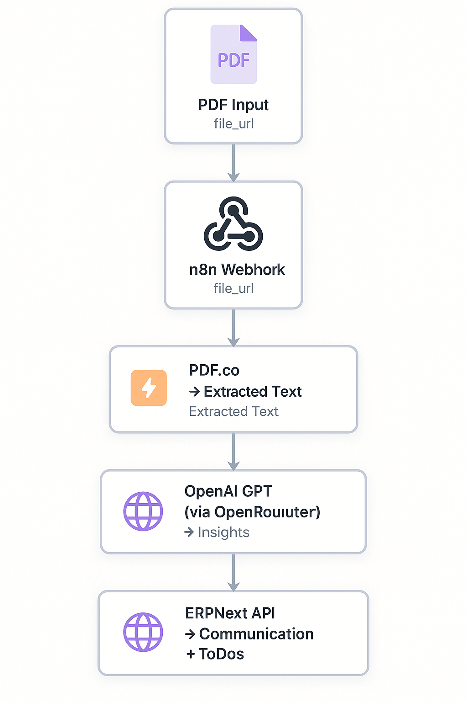

Fig: End-to-End Workflow from PDF

Upload to ERP Next Notification

1. **PDF Upload via Webhook**

The user sends a POST request containing the PDF file URL and file type to an n8n webhook. This initiates the automation flow.

1. **PDF.co Text Extraction**

n8n uses PDF.co’s API to extract readable text from the provided PDF. The output is validated to ensure text was successfully extracted.

1. **OpenAI GPT Insights Generation**

The extracted bill text is sent to OpenAI GPT (via Open Router API). GPT analyzes it and returns deep insights, including usage trends, anomalies, and recommendations in a structured JSON format.

1. **ERPNext Communication and ToDo Creation**

The insights are posted to ERPNext via its REST API. A detailed communication (comment) is created under a bill entry, along with high-priority ToDo tasks for the top recommendations.

**API Payload Samples**

1.Webhook Trigger Payload (trigger_webhook.py)

|  |
| --- |
| {  "file_url": "https://example.com/sample.pdf",  "file_type": "pdf"  } |

2.OpenAI Request Sample

|  |
| --- |
| {  "bill_text": "Extracted bill content...",  "openai_api_key": "sk-xxxxx"  } |

3. ERPNext Post Payload

|  |
| --- |
| {  "erpnext_url": "https://electricitybill.m.erpnext.com/",  "api_key": "api_key",  "api_secret": "api_secret",  "analysis": { ... },  "bill_id": "001"  } |

**Input /Output Examples**

**Input: PDF Sample**

• Type: Electricity Bill (PDF)

• Source: Public sample bill

• URL:

https://puc.nv.gov/uploadedFiles/pucnvgov/Content/Utilities/MHP/SampleElectricBill.pdf

**Output 1: OpenAI (GPT) Analysis**

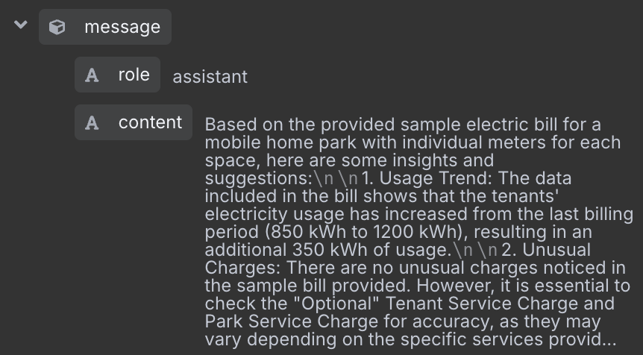

**Output 2: ERPNext API Response**

Communication Created:

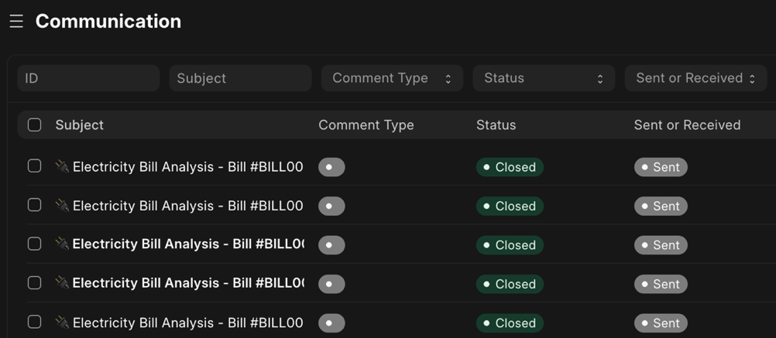

**Web flow:**

